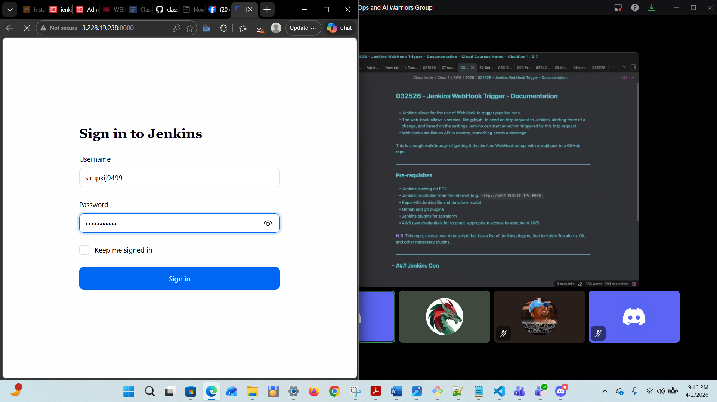

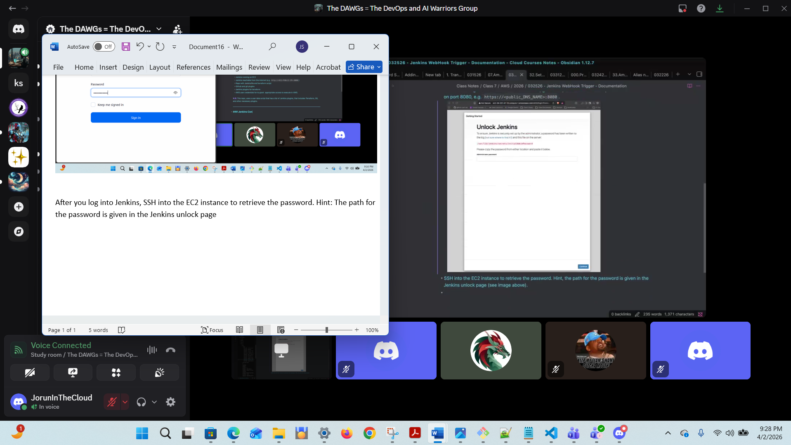
While the initial login password may be accessible via the EC2 log files, it may be easier to retrieve it directly in the instance.
After you log into Jenkins, you can SSH into the EC2 instance to retrieve the password. Hint: The path for the password is given in the Jenkins unlock page (see image above). You will need elevated priviledge (sudo).
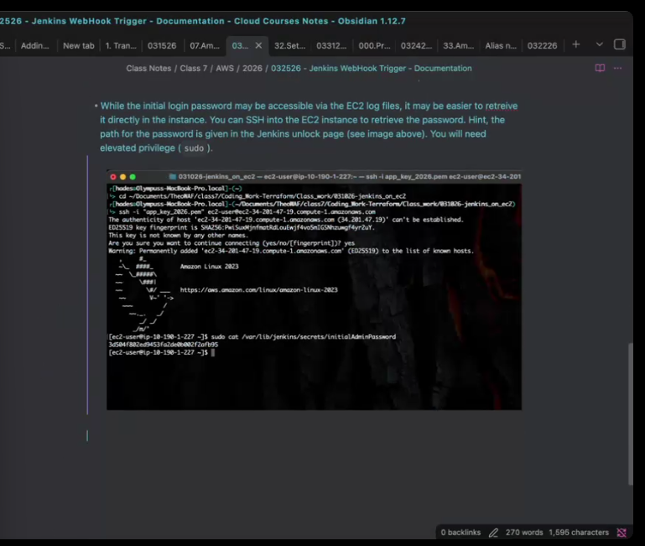

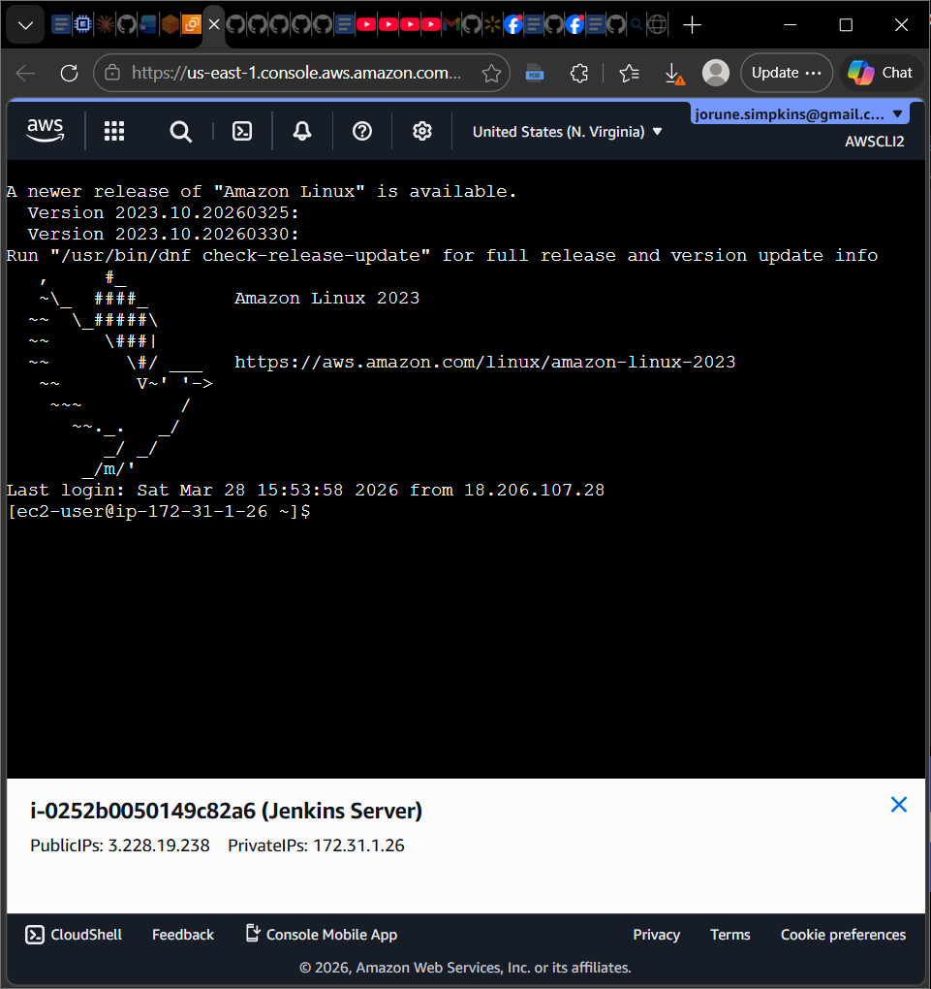
IT doesn’t hurt to verify if you need a few more plugins on install.
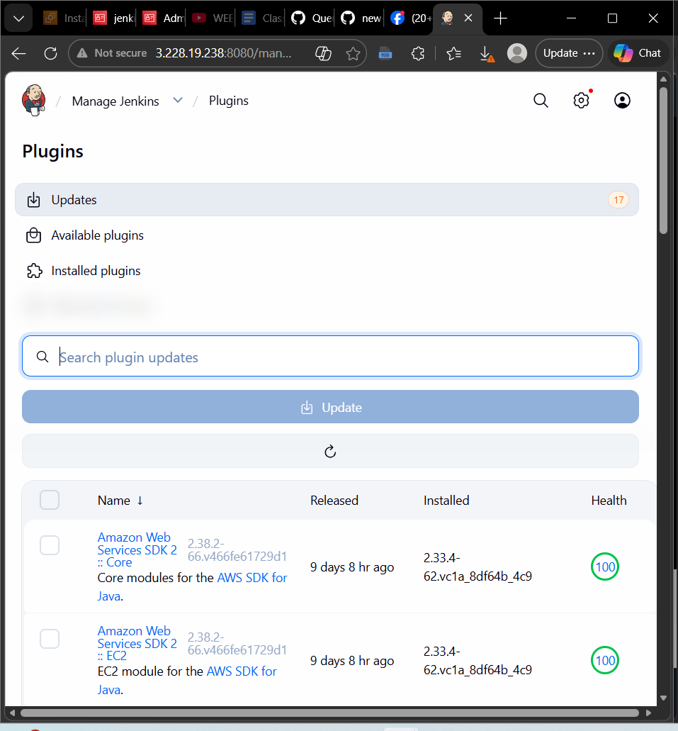

Wehook ->Queuefour97 / new-jenkins-s3-test -> Settings -> change the IP Address to the IP Address of the EC2.
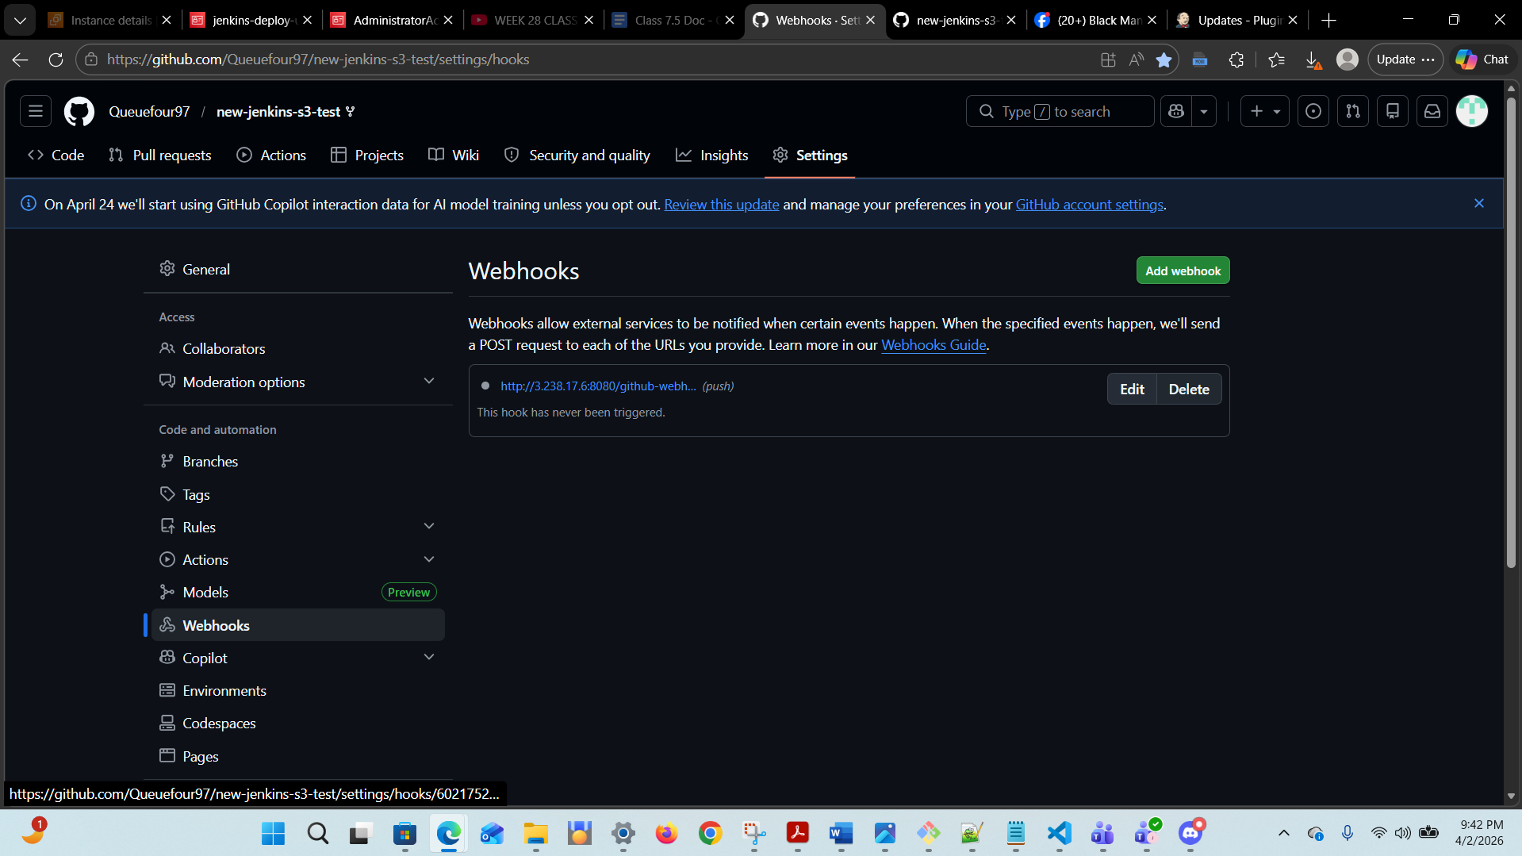

Note: Practice using Mark Down
Save the changes in the Github -> Settings -> Webhooks and go back to Terraform. Make a small change to the terraform file ->Save-> Run: git add . -> git commit -m "Jorune's Jenkins Test" ->git push; before all of the changes; Then run: terraform init -> terraform validate ->terraform apply

Go to Jenkins - > click on Jenkins icon -> web_hook_lab ->

Ensure that the ‘Script Path’ is set the ‘Jenkinsfile’. Then click ‘Apply’ then ‘Save’ (see screenshot below)

